React Document Document
Online practice : https://codesandbox.io/s/old-morning-d9rc9

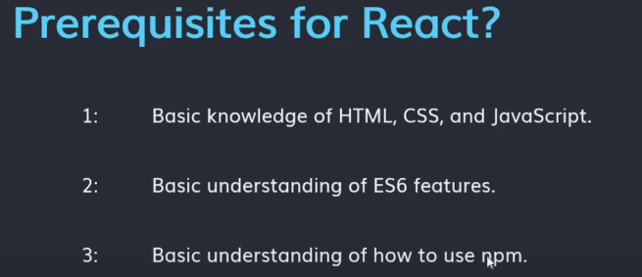

what is alternate of NPM =>(Yarn)

